**EXAMPLE on Esri Forum:**

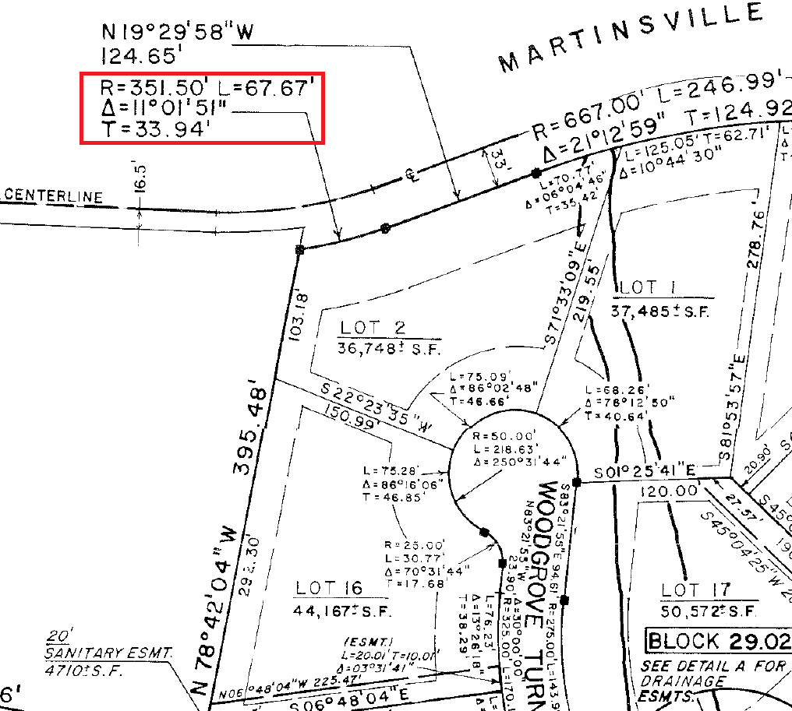

**BEN OAKS example: R = 600 A = 344**

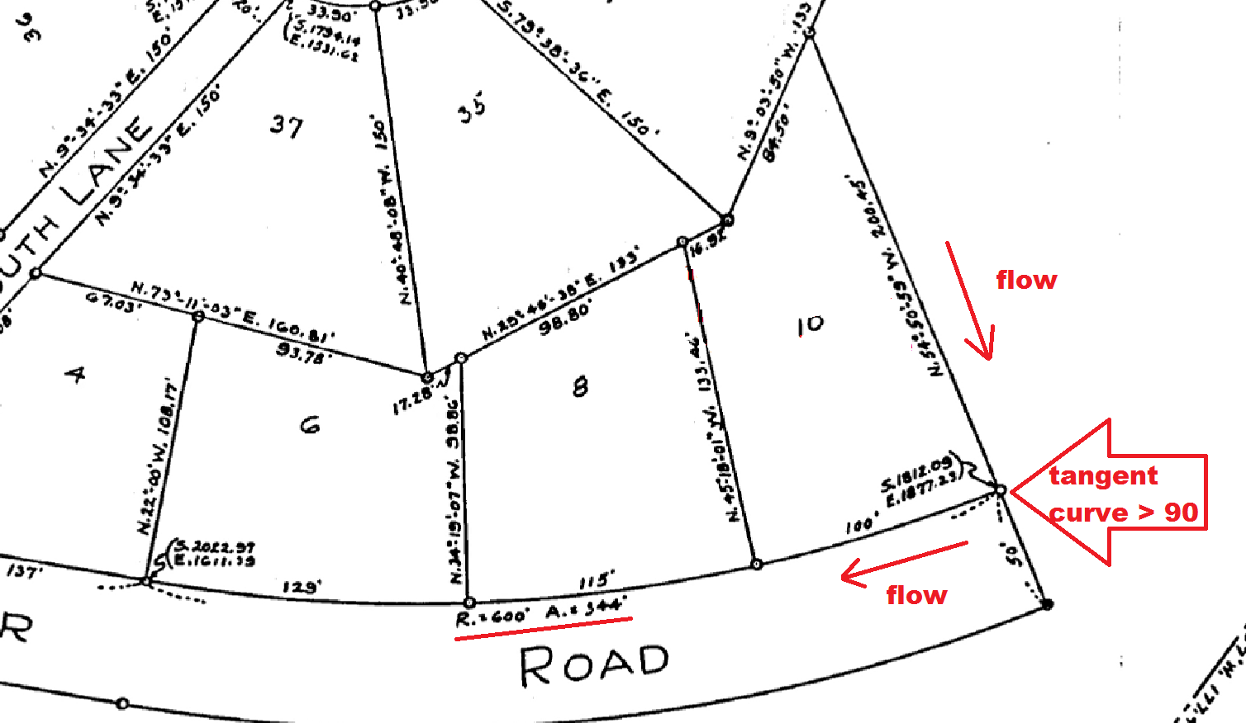TO CALCULATE THE DELTA **32-50-58** USE ArcGIS’s CURVE CALCULATOR using the given

Radius and Arc… in this case: **R = 600’ and A = 344’**

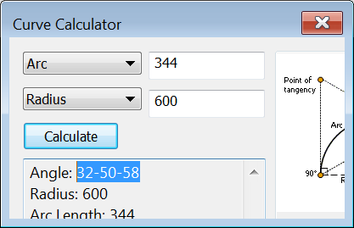

the segment with the bearing of **N 54-50-59 W** is tangent to the curve in question.

**FLIP IT TO COME TOWARDS THE CURVE** **S 54-50-59 E**

The **Radial Bearing** from this tangent line is a ***perpendicular*** bearing (90 degrees)derived by adding or subtracting 90:

**90** - **S 54-50-59 E = S 35-09-01 E**

180 + **S 35-09-01 E**= **N 35-09-01 W** (you need the bearings to point away from the radius point for this calculation)

**N 35-09-01 W** + **32-50-58** (the Delta) = **N 67-59-59-W**

(**Add the Delta since curve *approaches the West*** *axis* or S 90 W).

(**Subtract the Delta if curve *approaches the East*** *axis* or N 90 E).

The radial bearing you want will be the opposite direction of the previous calculation or

**180 + N 67-59-59-W = S 67-59-59-E** (**Radial Bearing**)

The **Radial Bearing and Chord bearing** can be calculated by taking **half** the delta **32-50-58** **/ 2 =** **16-25-29**

and the (**Radial Bearing** + 180) = **N 35-09-01 W** then add the 2 together (**35-09-01 + 16-25-29**) to get the **Radial Bearing to be ENTERED IN TRANSVERSE:**

**N 51-34-30 W** **(MORE ACCURATE)** of the **midpoint** of the curve.

The **Chord bearing** **(LESS ACCURATE)** is perpendicular (90 degrees) to this bearing

**90** - **N 51-34-30 W** = **S 38-25-30 W**.

FOR CONVERSIONS: <http://www.satsig.net/degrees-minutes-seconds-calculator.htm>

Source: <https://community.esri.com/thread/191227-cogo-finding-the-chord-radial-or-tangent-direction-for-a-non-tangent-curve>

